**LAB-6 (program)**

**PROGRAM 6. ORDER PROCESSING DATABASE**

**Consider the following relations for an Order Processing database application in a company.**

**CUSTOMER (CUST #: int, cname: String, city: String)**

**ORDER (order #: int, odate: date, cust #: int, ord-Amt: int)**

**ITEM (item #: int, unit-price: int)**

**ORDER-ITEM (order #: int, item #: int, qty: int)**

**WAREHOUSE (warehouse #: int, city: String)**

**SHIPMENT (order #: int, warehouse #: int, ship-date: date)**

**i. Create the above tables by properly specifying the primary keys and the foreign keys and the foreign keys.**

**ii. Enter at least five tuples for each relation.**

**iii. Produce a listing: CUSTNAME, #oforders, AVG_ORDER_AMT, where the middle column is the total**

**numbers of orders by the customer and the last column is the average order amount for that customer.**

**iv. List the order# for orders that were shipped from all warehouses that the company has in a specific city.**

**v. Demonstrate how you delete item# 10 from the ITEM table and make that field null in the ORDER_ITEM**

**table.**

**Create table:-**

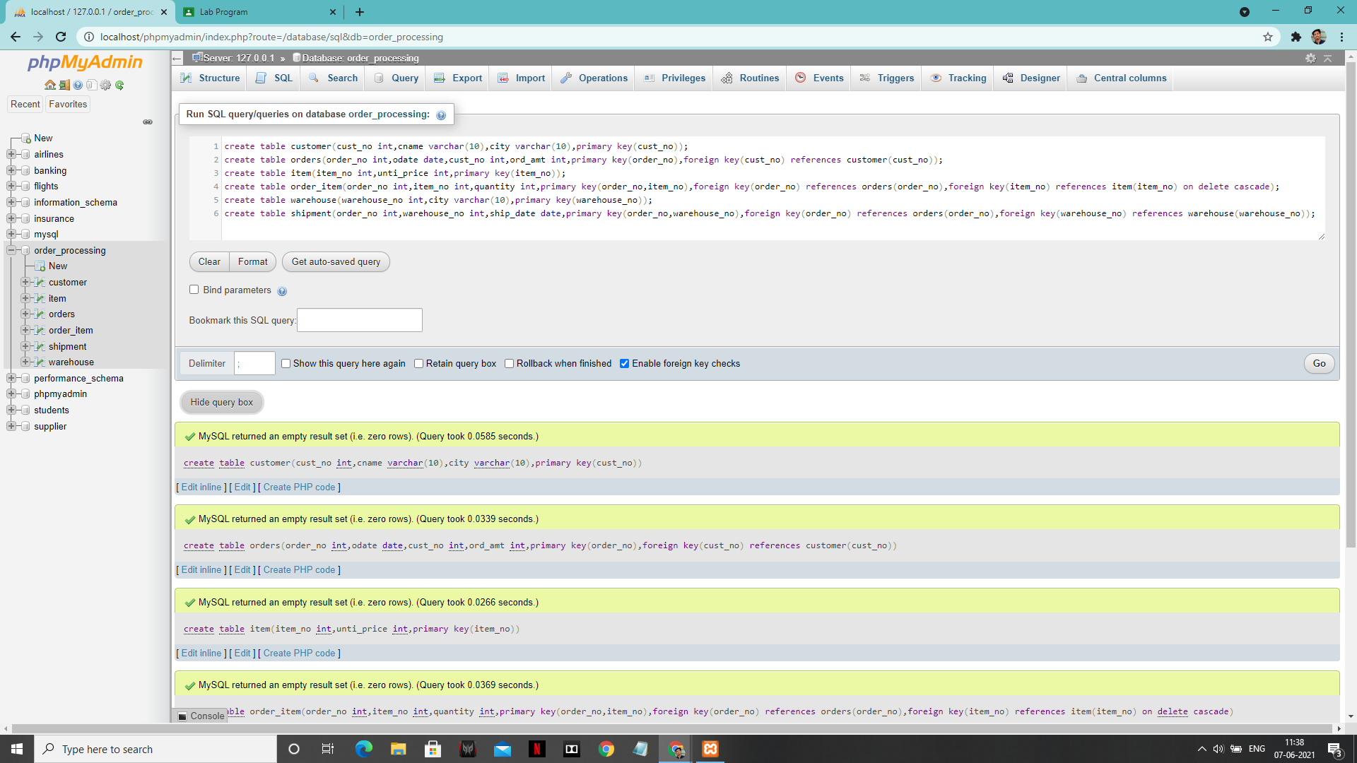

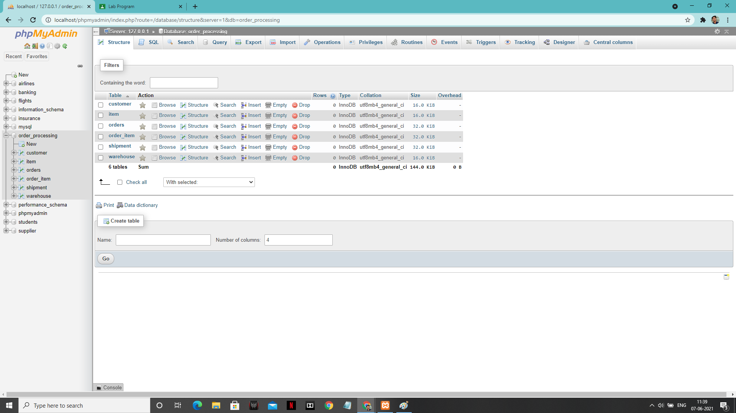

1. **Enter tuples for each relation.**

**‘Customer’ table:**

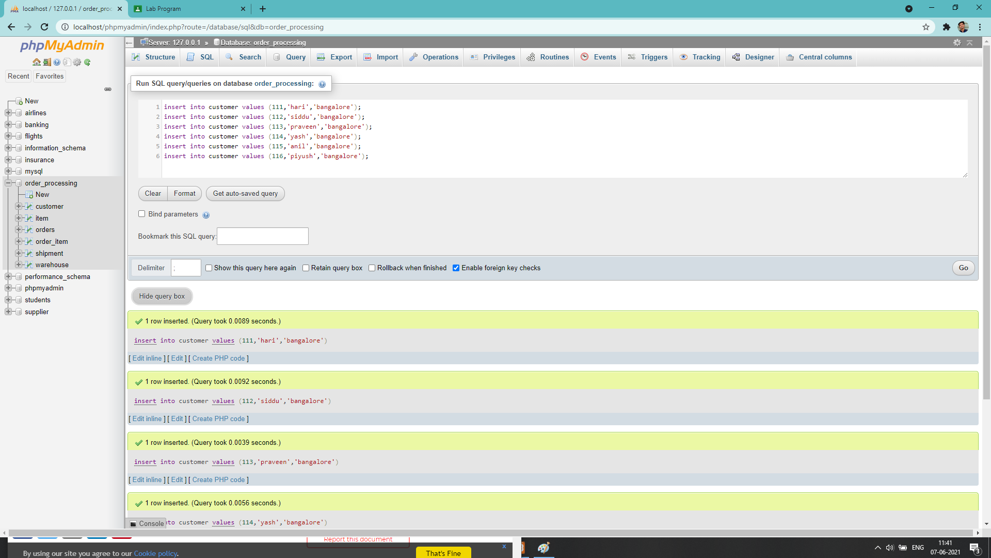

**‘Item’ table:**

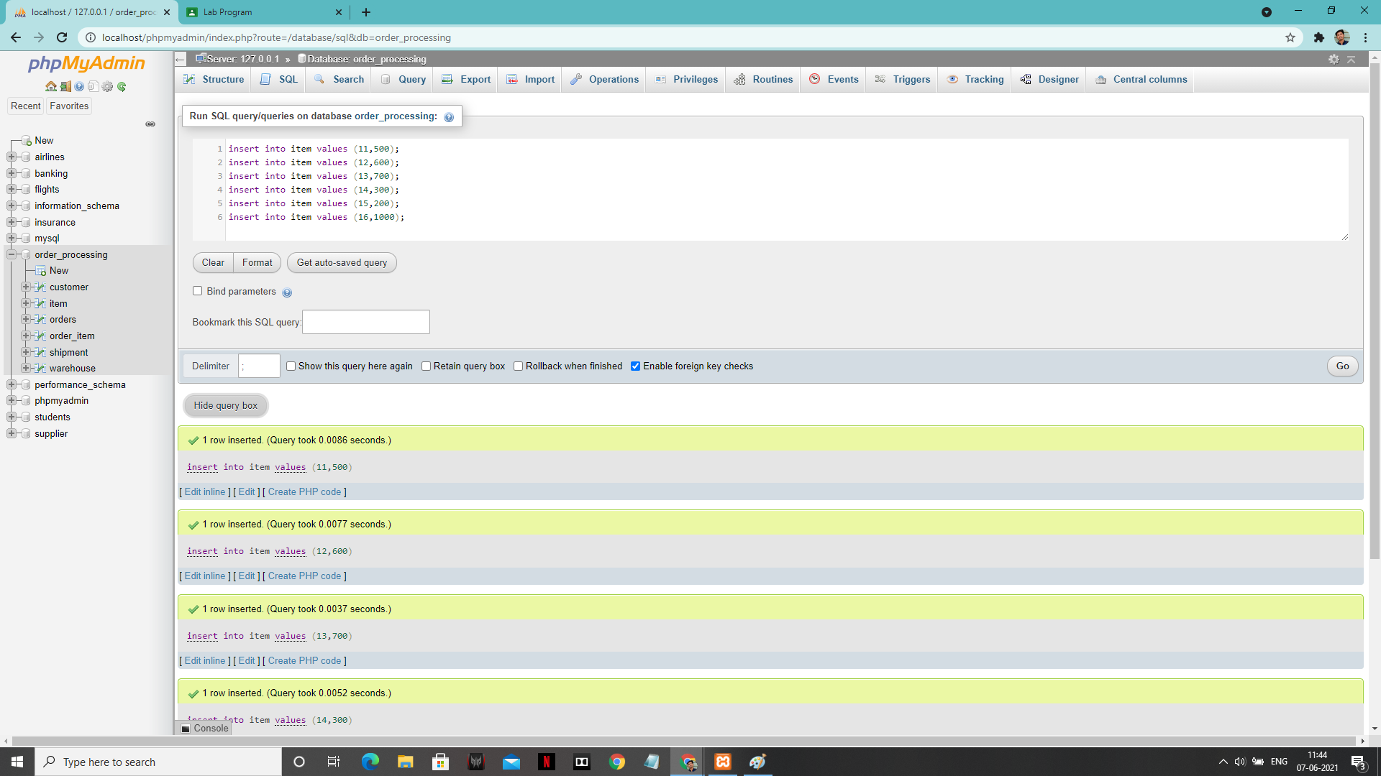

**‘Order’ table:**

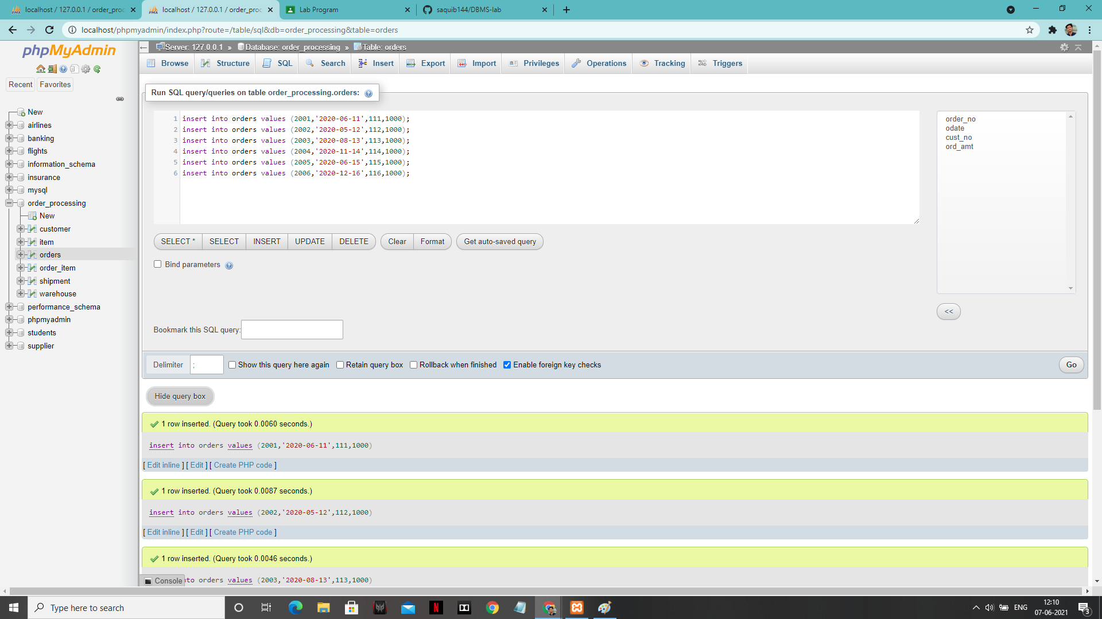

**Order_item value: -**

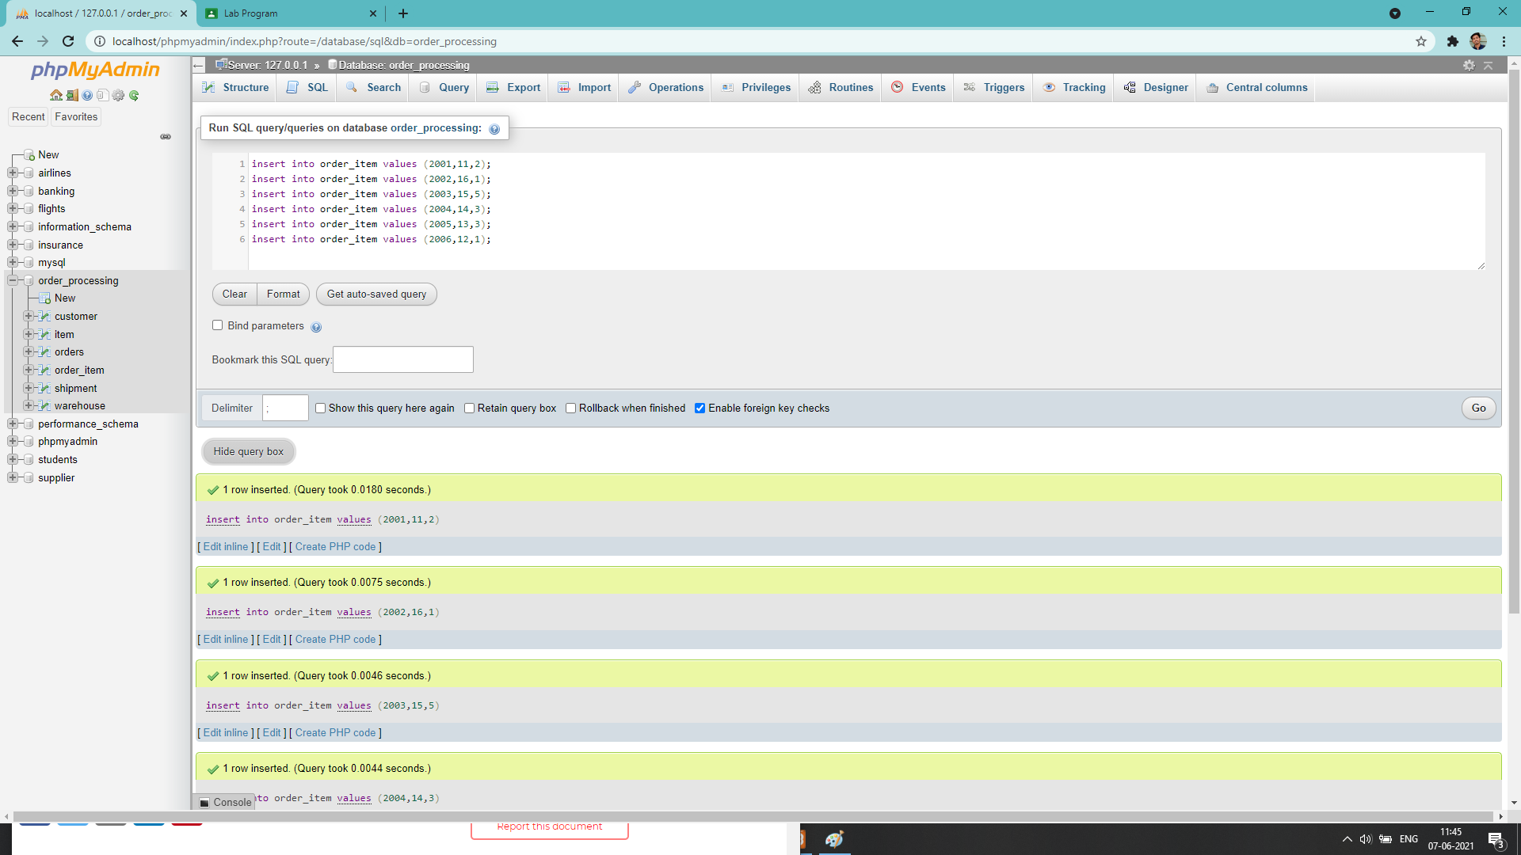

**Shipment table:**

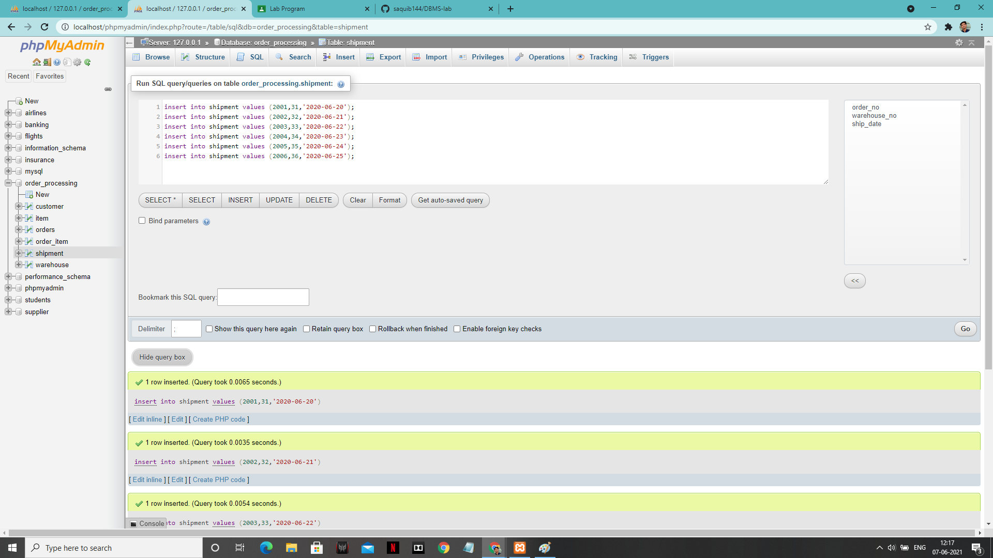

**Warehouse table:-**

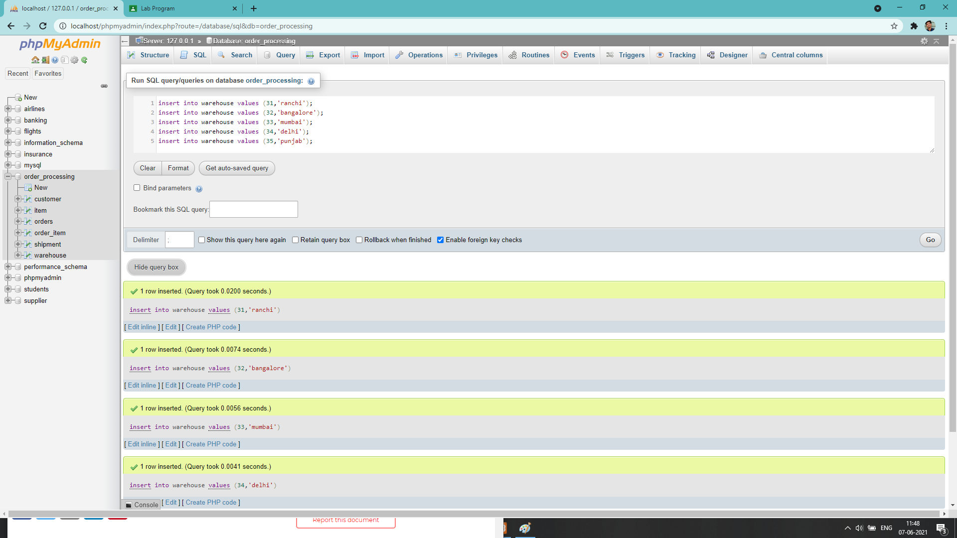

**1:-**

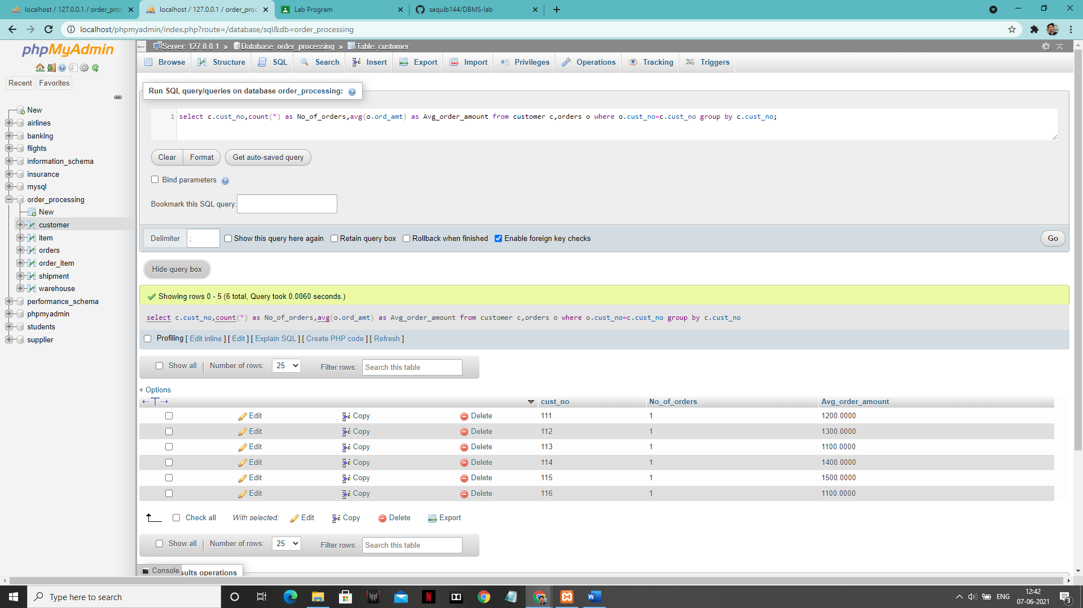

**2:-**

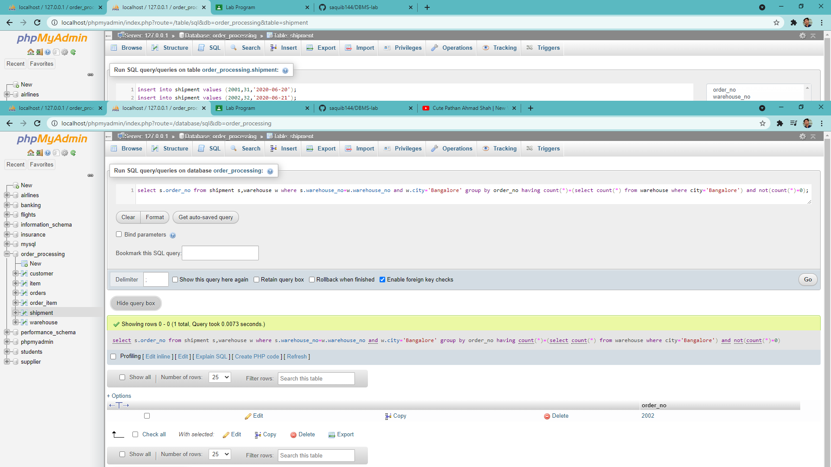

3:-

